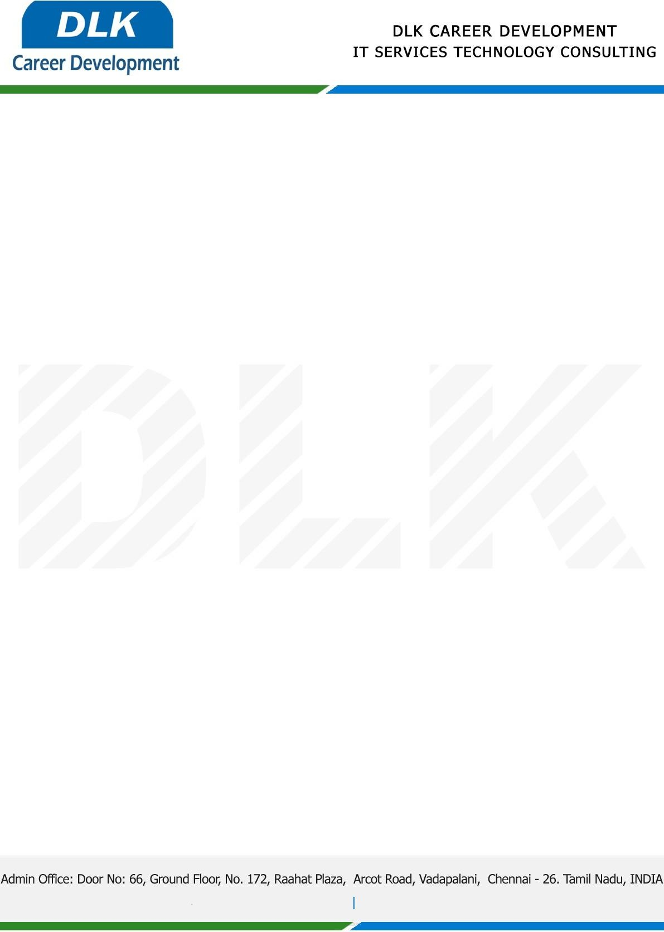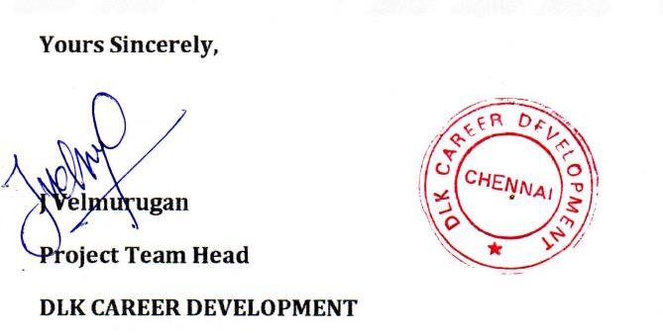

Date: 03 / January / 2022

**To**

Department of MCA ([Computer Application),](https://www.cseindia.org/) Head of Department,

Vels University, Chennai - 600117.

# Sub: Letter of Project Acceptance

This is to certify that **MS RENO N (REG NO: 21304254)** that final year student of has accepted her Project Work duration from 0**6th January 2023** to **20th May 2023** under the domain **“Java”.** During the, all information and data collected from you should be kept confidential.

**Topic:** An Implementation of E complaint analysis for quick response to Citizen Complaints

We appreciate your interest in **DLK CAREER DEVELOPMENT**